R. Reports Menu: H. Life Insurance Report

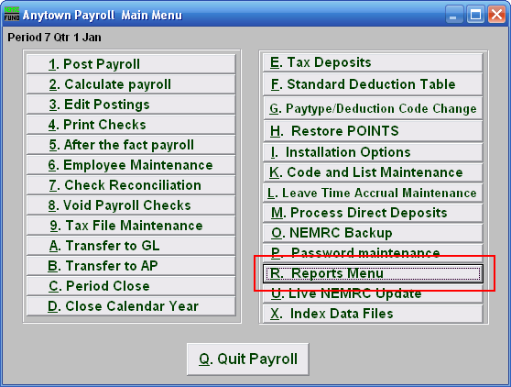
Click on “R. Reports Menu” from the Main Menu and the following window will appear:
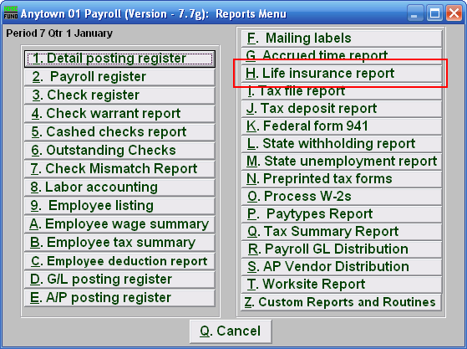
Click on “H. Life insurance report” from the Reports Menu and the following window will appear:

Life Insurance Report

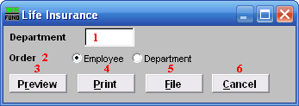
- Department: Select the Department you want this report to be for.

- Order: Click to choose whether this report prints in order of Employee number or in order of Department.

- Preview: Click this button to preview this report. Refer to GENERAL PREVIEW for more information.

- Print: Click this button to print this report. Refer to GENERAL PRINTING for more information.

- File: Click this button to save this report on this computer. Refer to GENERAL FILE for more information.

- Cancel: Click “Cancel” to cancel and return to the previous screen.

